

**FROM:**

**TAYYAB ALAM**

**FA22-BSE-043**

**LAB TASK: 03**

**FOR:**

**SOFTWARE DESIGN & ARCHITECTURE**

**SECTION:**

**BSE: 5A**

**TO:**

**SIR MUKHTIAR ZAMIN**

**QUESTION**

Run the coding example on https://www.tutorialspoint.com/design_pattern/observer_pattern.ht m

• Add Detach method to the Subject

• In Demo you need to change the number of observers and then change the state to ensure that only active observers gets notified and their update method are executed only.

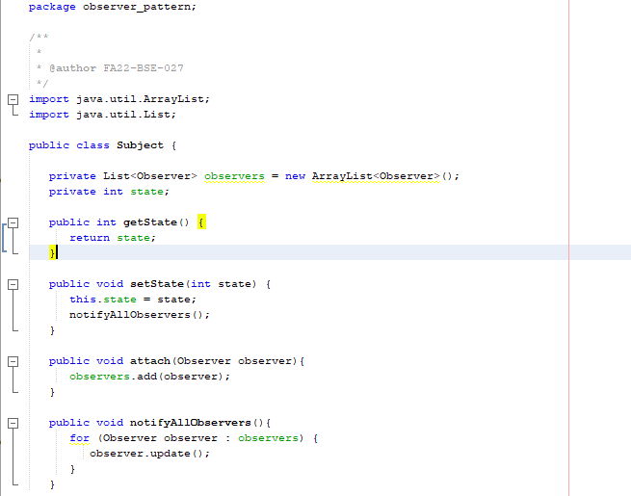

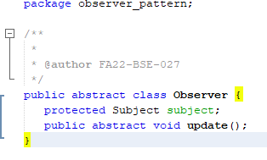

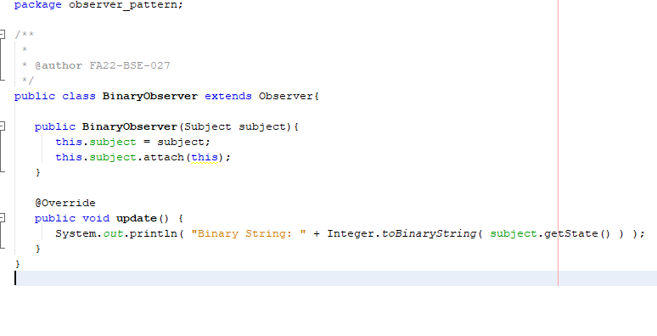

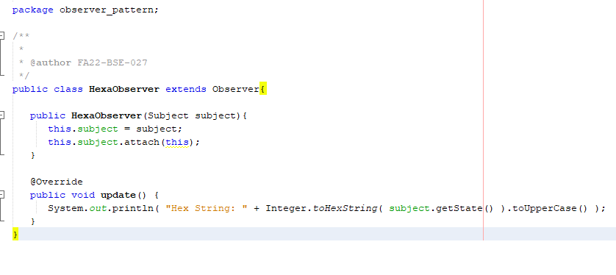

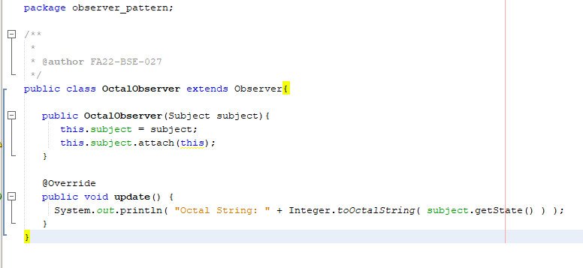

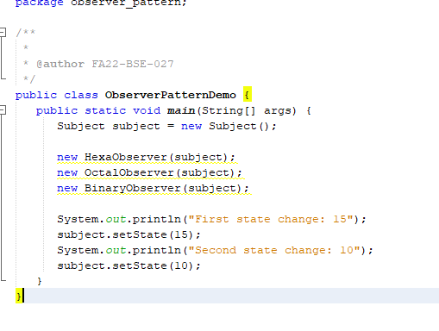

**Before Results**

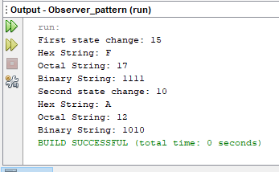

Add Detach method to the Subject

• In Demo you need to change the number of observers and then change the state to ensure that only active observers gets notified and their update method are executed only.

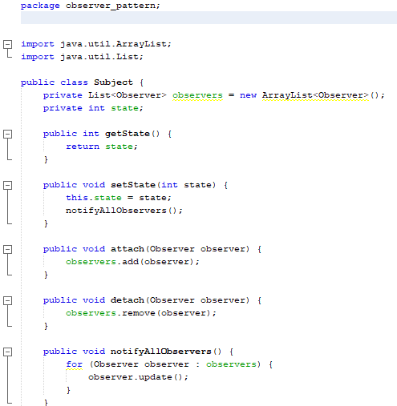

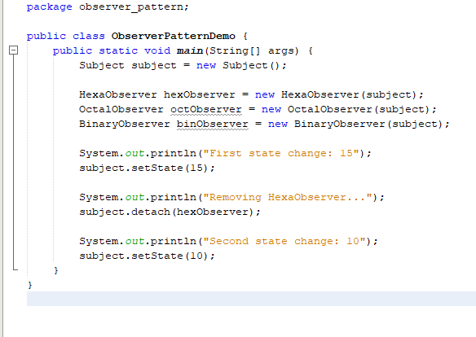

**After Results**

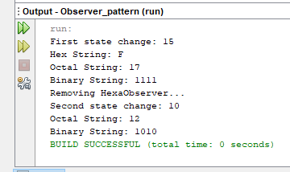

**Second Question**

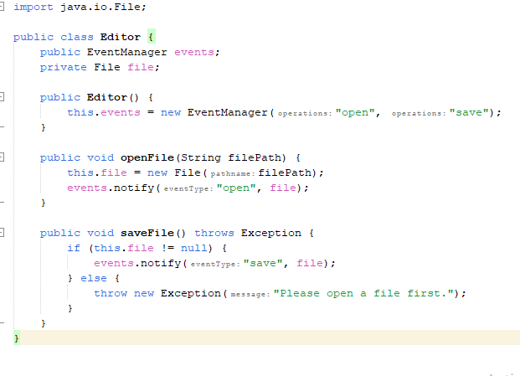

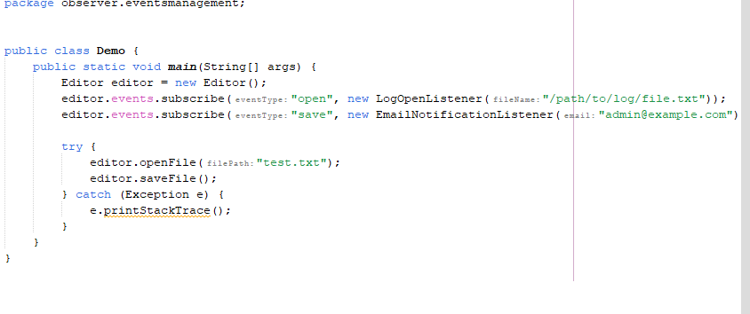

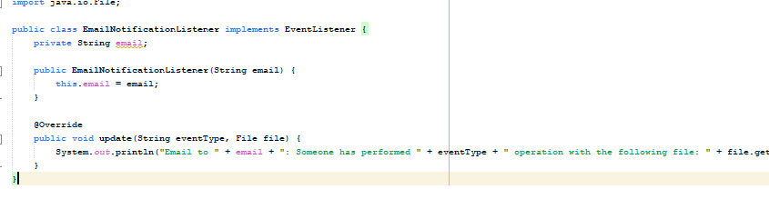

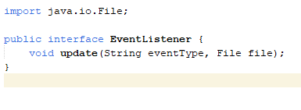

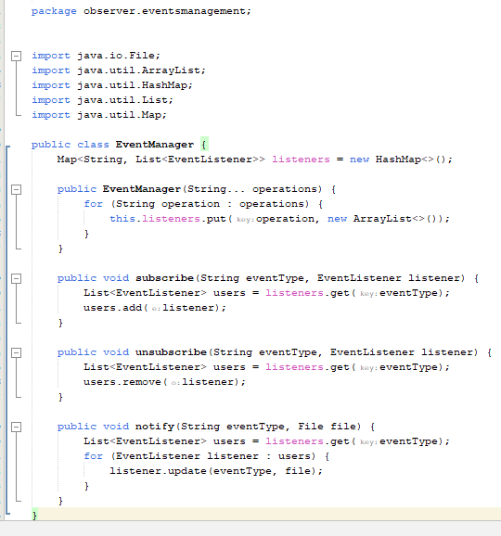

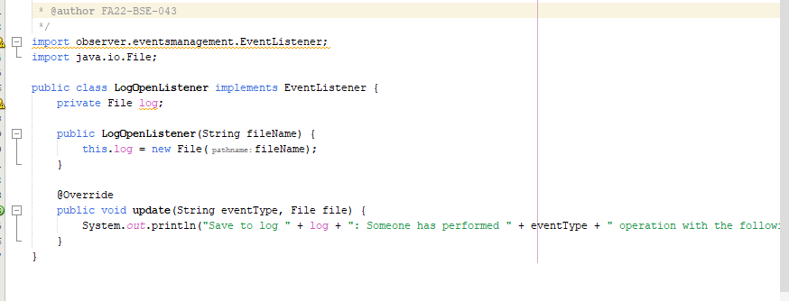

**RESULT**

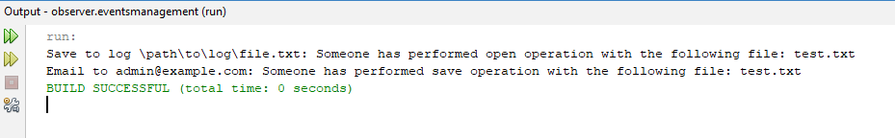

**THE END**